|  |  |
| --- | --- |
| TEAM ID | **PNT2022TMID53615** |
| PROJECT NAME | **SMART SOLUTION FOR RAILWAYS** |

# PROJECT DEVELOPMENT DELIVERY OF SPRINT-3

**SPRINT-3**

STEPS TO BE DONE

1. Payment screen in node-red
2. Checking in Web page
3. Generating QR code
4. Checking in QR scanner

# NODE-RED:

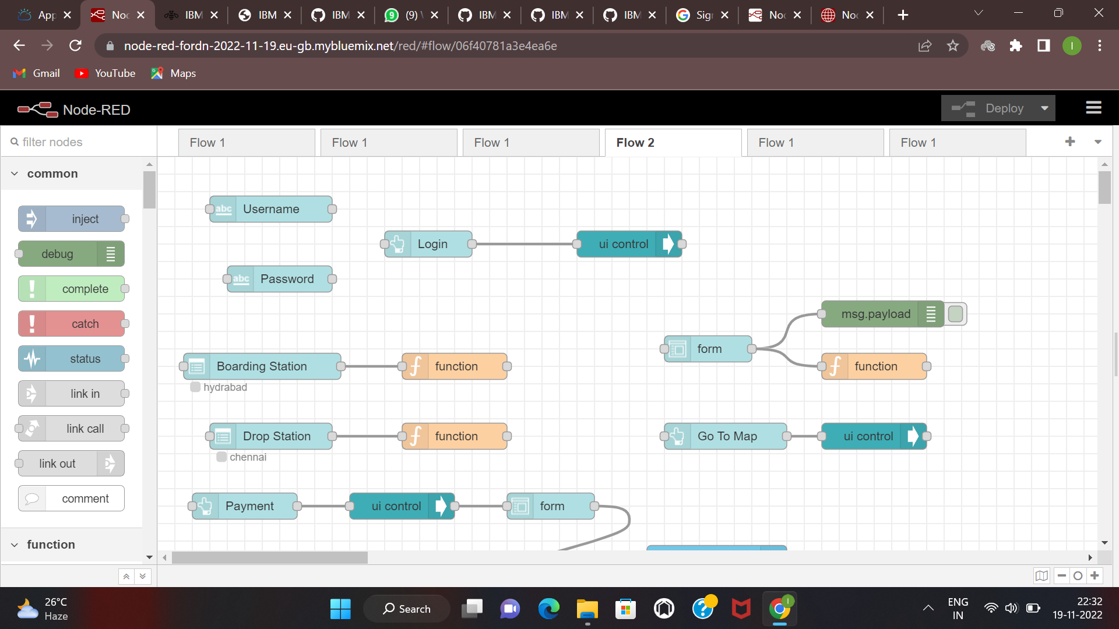

**PAYMENT WEB PAGE:**

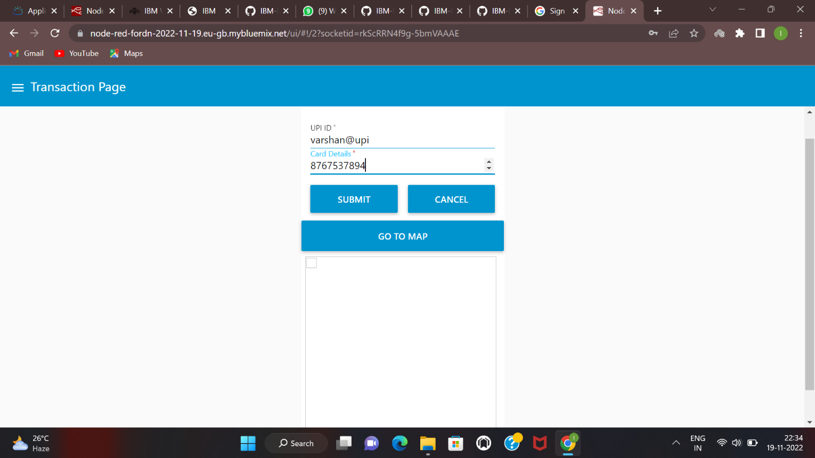

# QR Code:

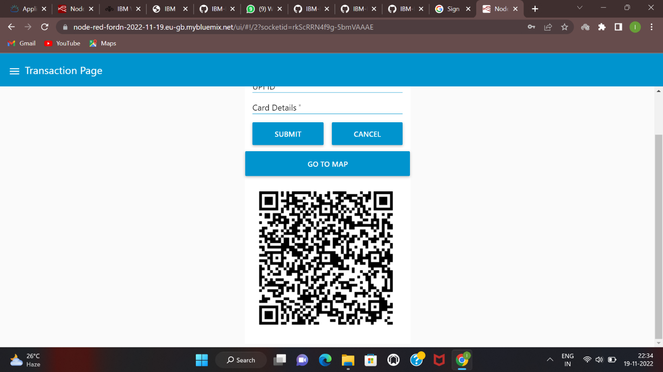

**CHECKING IN QR CODE SCANN**

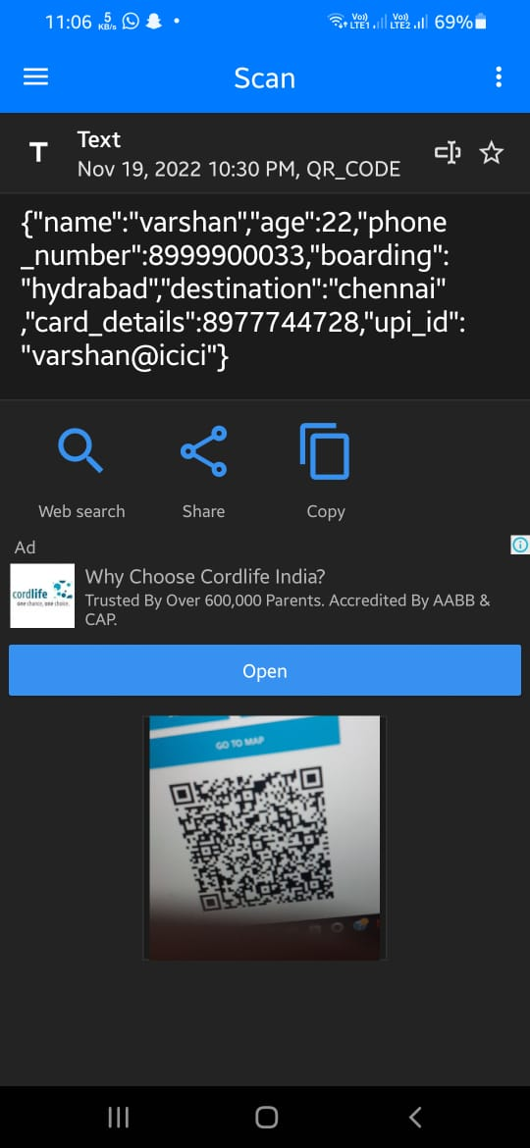

# CODE:

**Creating global variables:**

var json=global.get("json") json["boarding"]=global.get("board") json["destination"]=global.get("dest") json["card_details"]=msg.payload.card_details json["upi_id"]=msg.payload.name

var string=JSON.stringify(json); msg.payload=json msg.qrcodeinput=string; return msg;

# Boarding:

global.set("board",msg.payload ); return msg;

# Destination:

global.set("dest",msg.payload ) return msg;

# QR Template:

<img src={{msg.payload}} style="border:0px;height:300px; width:300px">

Success notification payload msg.payload="Ticket is genetrated/Reserved";

return msg;

# Seat Selection:

global.set('s1',0)

global.set('s2',0)

global.set('s3',0)

global.set('s4',0)

global.set('s5',0)

var a2 = [1,2,3,4,5]

global.set('a',a2) msg.payload = global.get('a') return msg;

Clear functionality in Seat Selection var a = global.get('a')

var s = []

for(let i=0; i<a.length; i++){ s.push(a[i])

}

if(s.length==0){

msg.options = [{"No seats avaliable":0}]

}

else{

msg.options = s

}

msg.payload = s return msg;